Instructions on setting up SJC arrival flights monitoring with Azure Kubernetes Service and MapR Data Fabric

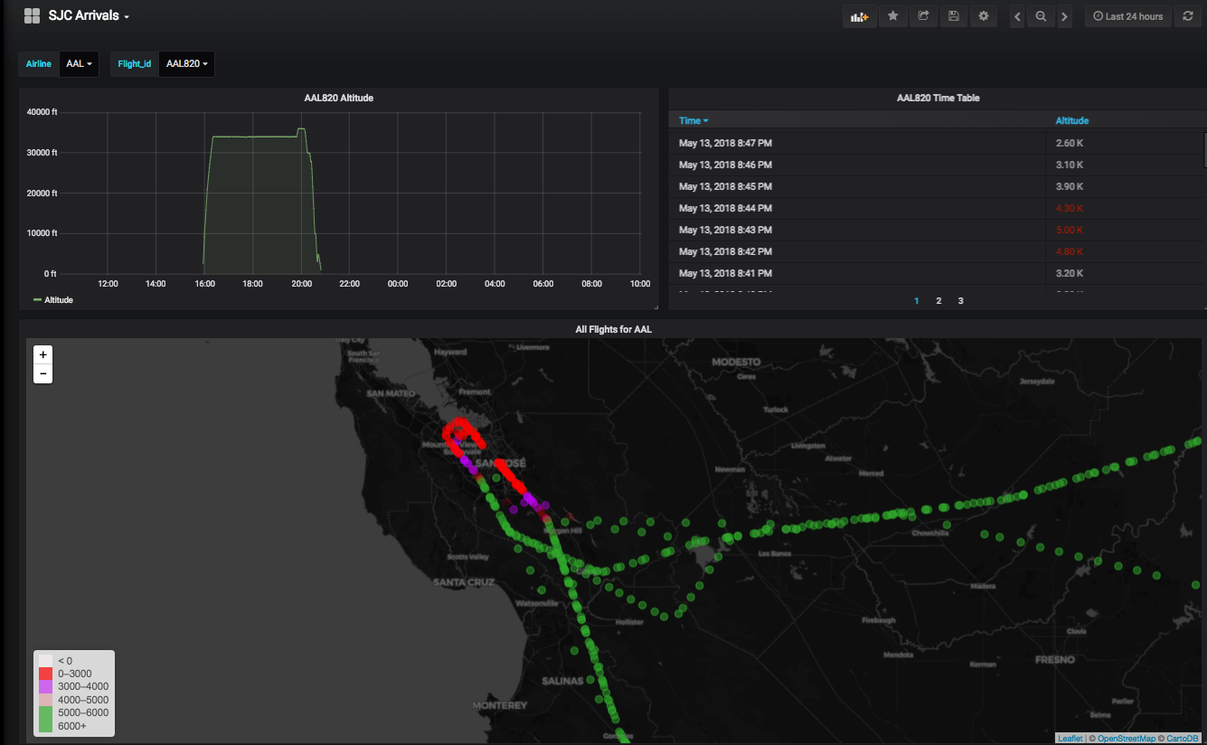

This demo provides the steps to setup a real-time monitoring system for San Jose Airport (SJC) arrival flights. It shows the flight tracks, flight numbers and altitudes of flights.

Step 1: Create a MapR Sandbox on Azure

Go to <https://tinyurl.com/y8q645xz>, fill out the form and record your resource group name and login name and password

Step 2: Create a AKS K8 cluster

Go to the Azure portal: <https://portal.azure.com>, select “Kubernetes Service”, then create a K8s cluster. The K8s cluster has to be in the same resource group as the MapR Sandbox in Step 1 above.

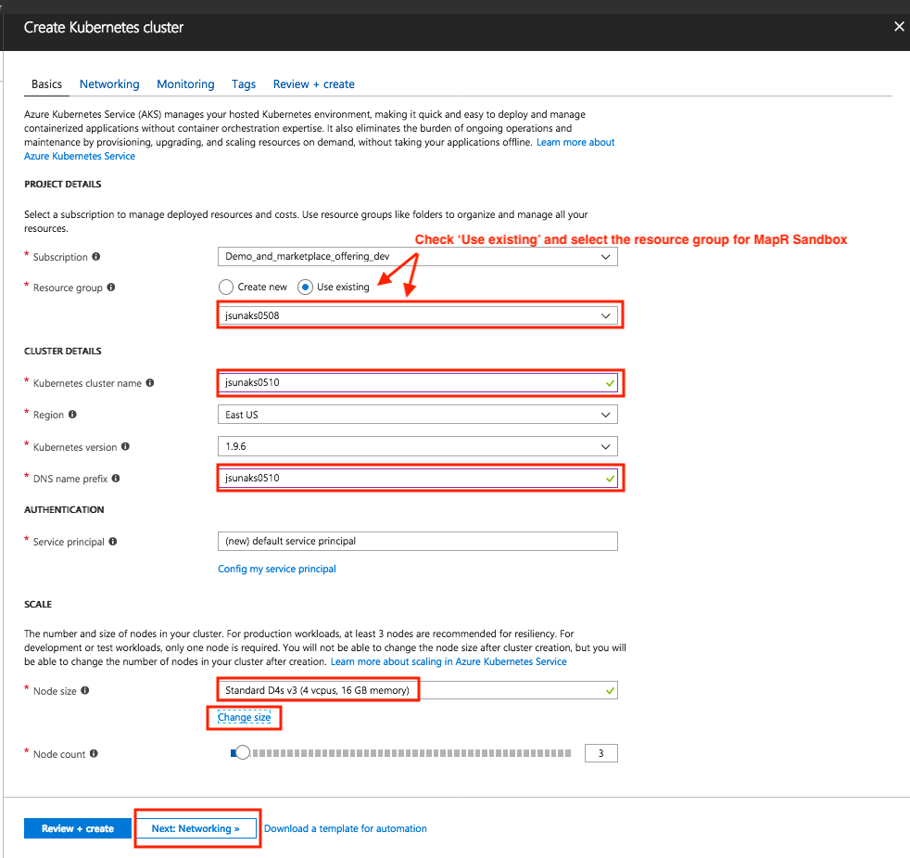

Select advanced networking configuration and use the same VNET “MapRSandboxVnet” as MapR Sandbox. Fill out the address range and DNS IP as described in screenshot below.

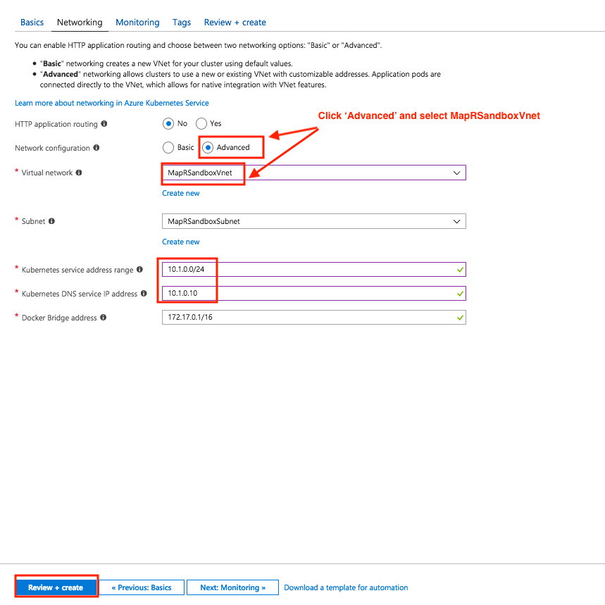

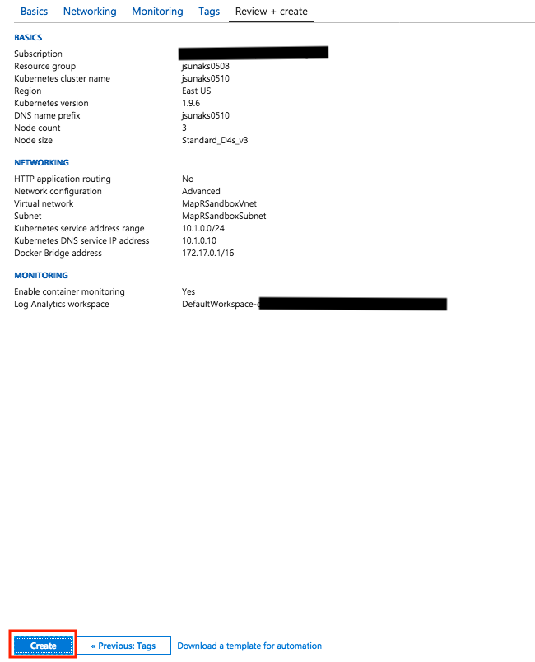

Step 3: Change AKS service principal role and owner so it can create load balancer in the VNET

Find the service principal name created by AKS by going to ‘Azure Active Directory’ -> ‘App regrations’ and search for the SP name, typically it has a form like this: <resource group name>SP-<number string>, e.g. jsunaks0510SP-20180510090736.

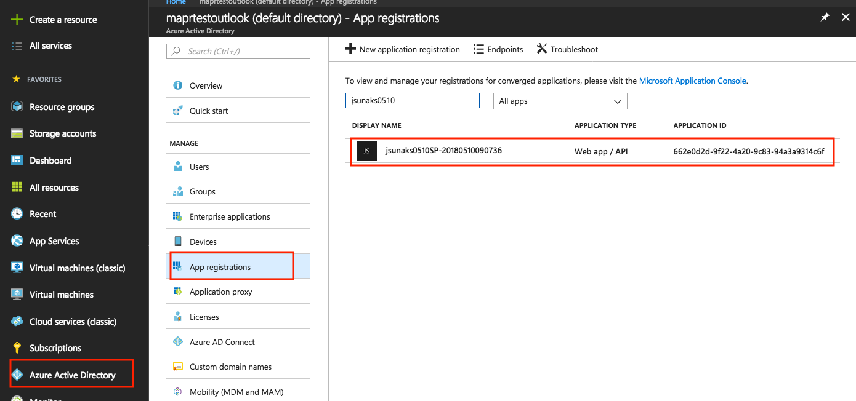

Select the service principal, click on ‘Settings’ -> ‘Owners’ -> ‘Add owner’, then search for your login name and add

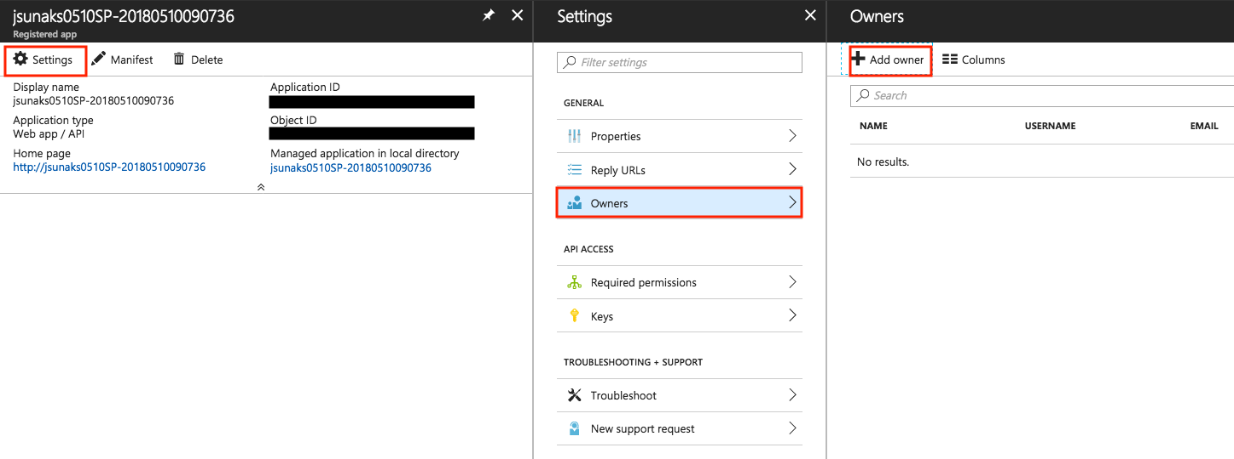

Now we need to assign a ‘contributor’ role to the service principal by going to the resource group created in Step 1, click on ‘Access control (IAM)’ -> ‘Add’ -> ‘Role’ -> ‘Contributor’ -> add the service principal name -> ‘Save’

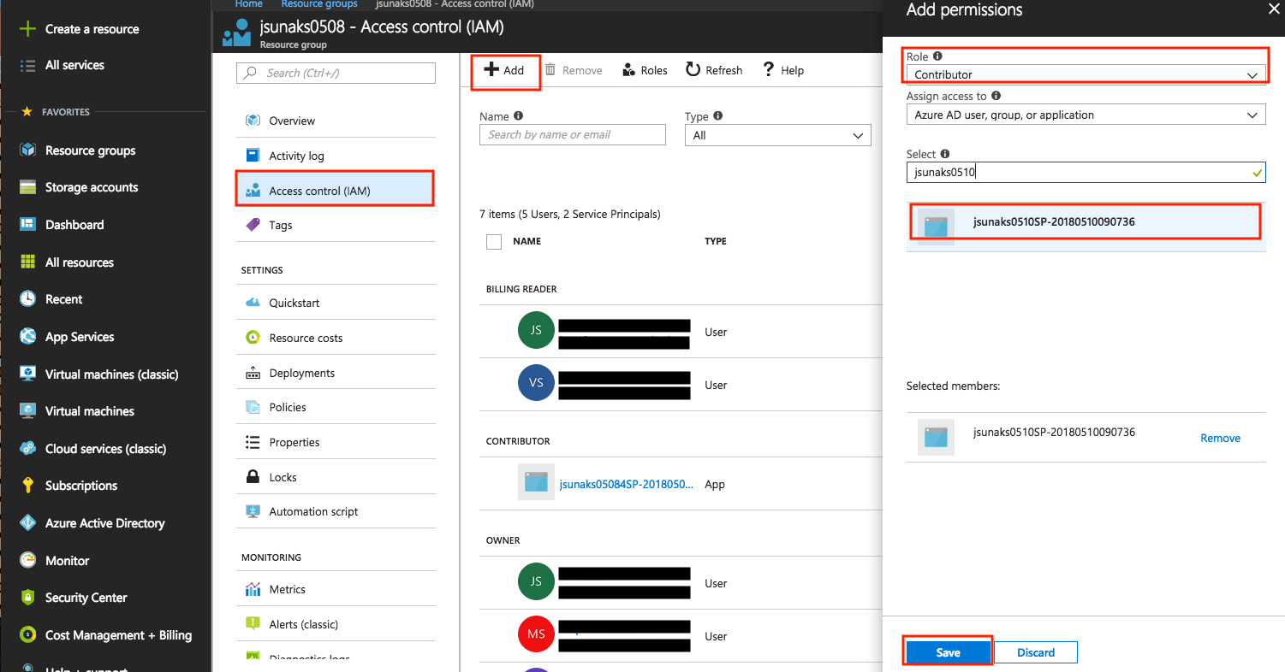

Step 4: Install Azure Cli Tool

login to Sandbox using the username and password as recorded in Step 1, sudo to become root

curl -L https://raw.githubusercontent.com/maprpartners/SJC/master/config-azcli | bash

Follow the instructions to login to your Azure account

use "az account set" if you have multiple subscriptions,

use "az aks list" to find out K8s cluster name from Step 2 if you forgot

Step 5: Configure K8s client on MapR Sandbox

In the MapR Sandbox as root:

git clone https://github.com/maprpartners/SJC.git

cd SJC

configure K8s

bash config-k8s

"kubectl get node -o wide" to verify it is working

Step 6: Install MapR Data Fabric for K8s volume plugin

bash inst_mapr_plugin

kubectl get pod --all-namespaces to verify, you should see mapr-kdfplugin-xxx daemon set running on each K8s slave

Step 7: Deploy the SJC flight monitoring demo

bash run

When completed, the script will provide a URL for you to look at the Demo

d an award-winning filesystem all at your disposal.